

**What do we mean by Trauma?**

The term trauma can refer to a wide range of traumatic, abusive or neglectful events or series of events (including Adverse Childhood Experiences (ACEs) and trauma in adulthood) that are experienced as being emotionally or physically harmful or life threatening. Whether an event(s) is traumatic depends not only on our individual experience of the event, but also how it negatively impacts on our emotional, social, spiritual and physical wellbeing. We are all affected by traumatic events in different ways.

In summary, psychological trauma can be understood in terms of the 3 **E**'s:

* the **E**vent
* how it is **E**xperienced
* and its **E**ffects

|  |  |
| --- | --- |
| **Type 1 Trauma** | **Type 2 or complex Trauma** |
| Sudden and unexpected events which are experienced as isolated incidents. Such as road traffic accidents, rape or terrorist attacks. This can happen in childhood or adulthood. | This term refers to traumatic events which are repeated, interpersonal and often (although not always) occur in childhood. This includes all forms of childhood abuse which is chronic and cumulative such as childhood sexual abuse, childhood physical abuse, witnessing domestic abuse and neglect. Domestic abuse is the most common experience of complex trauma in adulthood. |

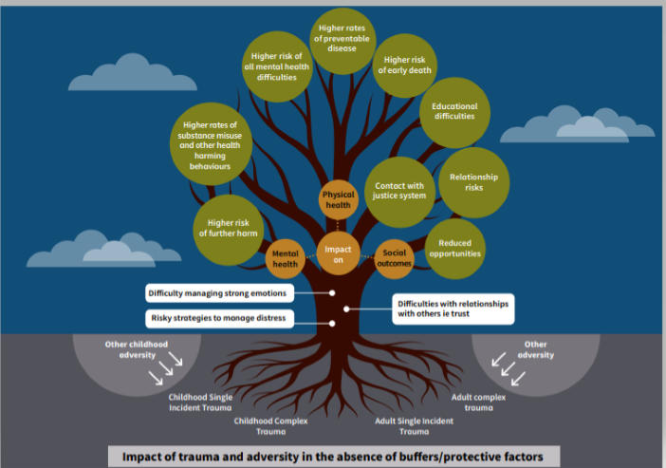

We are all exposed to some level of trauma in our lives. This can shape how we view the world and have a significant impact on our mental health, physical health, social outcomes and how we cope. This can lead to negative outcomes if we don’t have buffers or protective factors in our lives to help us cope. The NHS Education for Scotland have created the trauma tree (above) to give a visual representation.

This is not to say that these outcomes are inevitable but experiencing trauma and adversity does increase the risk of these. One of our goals at Move On is to work with everyone so that everyone has a greater awareness about this. Then take a strength based and trauma informed approach to help build in protective factors and buffers depending on that person’s needs. Many people have experienced of traumatic or adverse things in their lives and they cope on their own. It’s not about us taking over or asking anyone to talk about things they don’t want to. People are resilient and people who have experienced trauma have their own ways of coping, if they want support, we can talk about what has worked in the past and work together to build on what works for them. We do not need to know that someone has experienced trauma to work in this way.

|  |  |
| --- | --- |
| **Your Role IS:** | **Your Role IS NOT:** |
| * To listen * Show empathy and understanding * Work in a Trauma Informed way * Pass on any concerns * Signpost people on to specialist support if needed or ask support with this * Complete any paperwork to a high standard * Try some of the tools and activities * Tell us when you need support as well * Attend relevant training * Follow policies and procedures | * To be an expert on Trauma * 'Fix' everything or always find solutions * To be a counsellor, psychological or anything that is not your role * To use techniques or tools you don't feel comfortable with |

**Move On’s Pledge of Support**

Move On’s senior leaders have pledged their support to this approach. For more information our pledge is included on the National Trauma Transformation Programme Website here: [Leadership Pledge of Support - National Trauma Transformation Programme](https://www.traumatransformation.scot/about/pledged-support/) along with many other organisations across Scotland.

This is an on-going process, and we want everyone to be involved. We have started the process by focusing on the 5 key things that we have committed to with this pledge:

## **1: Value the Contribution of People with Lived Experience**

## **2: Show Courageous Leadership and ‘Walk the Walk’**

## **3: Support Staff Training and Development in Trauma Informed Practice**

## **4: Prioritise Staff Wellbeing**

## **5: Monitor, evaluate and improve**

**1: Value the Contribution of People with Lived Experience**

• We work with volunteers, staff and young people to co-design, co-produce and co-deliver training for other volunteers and staff

• We are doing interactive activities with the young people and volunteers in the mentoring and employability programmes to get feedback about their experience

• We run reflective workshops using the Trauma Lens to look at what can be improved, what is working well and what needs to be added. We will continue to do workshops like this and review progress each year

• The feedback from these sessions have directly led to actions plans being created and changes being implemented in practice

• We are embedding a strength-based approach and started using wellbeing plans

* We asked volunteers and young people what topics are important to them. These topics are now monthly topics these were created into a blog post based in the feedback from young people, volunteers and staff and these are on our website, social media and in newsletters
* We have designed and printed “Give us a shout” feedback posters to display in all four Move On bases across Glasgow and Edinburgh. These posters include a QR code so that people can easily share feedback – either anonymously, or with their details if they would like us to get back in touch.
* We have a social group with young people and Peer Champions help facilitate this group. The group covers a range of topics that are important to them and it’s a space to have fun
* We have a Volunteer Connection Group who contribute to the Volunteer Strategy, look at what we can improve on and provide invaluable feedback

**2: Show Courageous Leadership and ‘Walk the Walk’**

• Senior leaders and board members take part in a awareness sessions and they have supported embedding this approach into practice

• We have embedded this into our everyday paperwork, procedures, inductions and policies and we will continue to review this

• A short video has been created to explain the basics of this approach to everyone, raise awareness and show Move On’s commitment to this approach

• Training for all staff and volunteers is key, this has started and will be on-going. We have asked the staff and volunteers what training they would and we will built this into the plan

• We look at the Window of Tolerance as an organisation

• We are working together as a staff team to build this into the culture at Move On. We are doing this collaboratively with the staff, volunteers, young people and adults at Move On through training, activities, conversations, information sheets and day to day practice

* Senior management will be attending the Scottish Trauma Informed Leadership Training (STILT) with NHS Education for Scotland

**3: Support Staff Training and Development in Trauma Informed Practice**

• The staff members in the Edinburgh and Glasgow bases have completed the online modules created by NES, initial trauma informed and skilled training tailored to Move On, reflection workshops and training on the updated paperwork

• Practical toolkits have been created to support staff, volunteers, adults and young people at Move On and these will be reviewed and updated

• On-going continuous professional development and training opportunities are available and being created to support the development of this way of working

• We are building on the knowledge and experience of the people in Move On already as well as using the NHS Education for Scotland resources

• We are going to regularly run sessions to review how this approach is working in practice

• We created tailored training on Disclosures and Retramatisation to support staff and reassure them that they are not expected to ‘fix’ everything or be trauma experts but to build on our practice and use this approach to help us to recognise signs and enhance our responses • We run a Trauma Awareness Session for volunteers

• There will be on-going trauma training for volunteers and staff based on their suggestions for further training

• We have updated our paperwork to embed these principles into our work

• We want to learn from each other, if you have lived experience of trauma and you would like to get involved in co-producing and/or sharing ideas for training please get in touch (my details are at the bottom of this sheet)

* We run quarterly staff reflection sessions and promote the importance of reflective practice
* A staff member attends the Collaborative Peer Learning Network regularly to learn from others and share our journey
* A staff member is part of the Trauma Ambassadors Network with Edinburgh Council to learn from others and feedback any information from this with all staff
* We are working with NHS staff to look at training for all staff
* We have run basic information sessions on the UNCRC with staff and volunteers
* All staff in the mentoring projects have completed online Modules on the UNCRC
* Mentors and young people have been doing activities on the UNCRC articles and we are embedding this more into daily practice now that it is in Scottish law. This will be ongoing along with training for everyone

**4: Prioritise Staff Wellbeing**

• Move On staff can access counselling anonymously and we have a health and wellbeing group to organise health and wellbeing activities

• All staff should get regular formal support and supervision and are able to have informal support and supervision with their line manager or other staff

• We have review and reflection sessions so staff can share what’s working and what’s not and share practice. We make changed based on the feedback from staff at these sessions

• In the Health and Safety Policy there is a section that has been added to includes clear information about support for staff, information on the trauma informed approach and the risks to our own wellbeing from secondary and vicarious trauma

• The Health and Wellbeing group organise a range of activities for people to get involved in such as yoga, shiatsu, book clubs, film clubs, baking, dance, creative activities and gift exchanges. These all promote staff wellbeing, the importance of self-care and bodywork for us all.

**We have wellbeing perks that were voted for by staff:**

-Twice per year we will offer a £20 voucher for a supermarket of your choice

-Twice per year we will offer a £20 massage/pamper voucher of your choice

-We will offer £10 towards going to the cinema once per year

-We will arrange team fun days within each base (An activity/Lunch/Dinner)

-All bases at Move On have their own budget as well to focus on things in person to do as a group or individually and this is reviewed yearly

These don’t suit everyone, so any suggestions staff have on this are welcome. Please let a member of the health and wellbeing group know if you have any suggestions.

**5: Monitor, evaluate and improve**

• We get feedback after all training sessions and use this to improve things

• We are using the Trauma Lens tool; this helps us to create action plans and we will continue to review this. We suggest that all bases at Move On do this within their teams

• We get feedback from staff, volunteers, young people and adults we work with through regular support and supervision (informally and formally)

• We send surveys, do interactive activities and gather feedback from these. If there are things that we can’t put into action we will explain why and have those discussions

• We regularly write case studies and create videos to share stories and the impact of the services to show the soft outcomes and significant impact the different services have had on people’s lives

* Staff complete their own training logs after each training
* We are going to be using the Trauma-Informed Roadmap to review the work we have done so far

**If you have any suggestions about how we can work towards these 5 key areas, please get in touch with me and/or your line manager know.** This is on on-going process to embed this in the culture at Move On and this is not an extensive list of what we are doing this is just some examples of what we have done or are working on so far.

**For more information, please contact Amy on** [**amy.dunn@moveon.org.uk**](mailto:amy.dunn@moveon.org.uk) **or you can phone on 07395788688**

*The information from this sheet is based on Information from the NHS Transforming Psychological Trauma Knowledge, Skills Framework and Training Plan, The National Trauma Transformation Programme and Move On's knowledge and practice.*