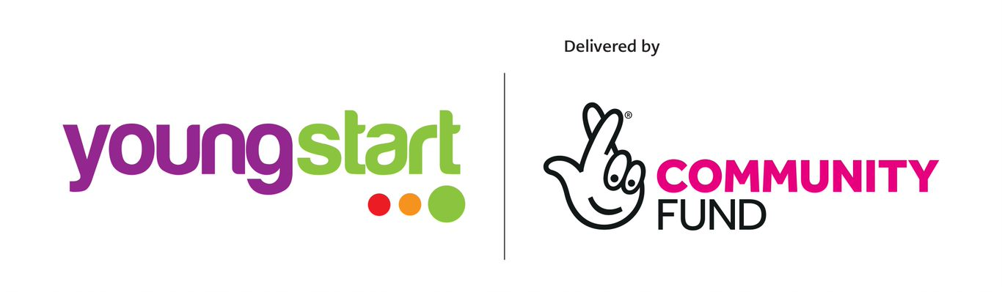

Move On

Job Description

Job Title: Development Worker
Responsible to: Assistant Manager
Location: Glasgow
Salary: £21,362 to £23,735 (It is Move On policy for candidates to start on point one of the salary scale)
Hours: 35 hours per week to be worked flexibly – will include office hours (Monday to Friday 9am – 5pm), regular evenings and some weekends. Participation in the on-call safety phone rota is also required.

Main Purpose of Job: To support the work of our young people services, working directly with individuals and groups. The role is to support young people to achieve positive life experiences through mentoring, volunteering and training, and to identify, access and sustain employability opportunities through delivery of accessible and relevant advice and information on a wide range of topics.

Move On offers:

- 25 days annual leave and 9 bank holidays for the first 2 years of service, increasing to 28 days and 9 bank holidays after 3 years;
- Flexi-time;
- Option to buy additional annual leave;
- Annual personal volunteering day for staff;
- Individual training allowance and commitment to CPD;
- TOIL system.

Key Functions and Responsibilities:

- Establish and support ‘matches’ between service users and volunteer mentors, including peer support;
- Develop, prepare and deliver group work and training on a variety of topics;
- Co-ordination of a range of qualifications including Community Achievement Award; Employability, Core Skills Communication and Personal Development Awards;
- Participate in the recruitment, training and support of volunteers including volunteer peer educators and volunteer mentors; ensuring a positive and supportive volunteering experience;
- Establish good external relationships and develop links with statutory and voluntary organisations in order to promote and develop all of Move On’s services;
- Complete case recording, monitoring and evaluation using various case management systems and databases;
- Participate in the safety-phone rota; ensuring that volunteers adhere to Move On’s lone working policies at all times;
- Complete relevant assessments and reviews of the young person’s needs;
- Supervise and support trainees, sessional workers, volunteers and students as requested by the manager;
- Ensure that the safety and welfare of individuals are protected in accordance with Move On’s safeguarding policies and procedures;
- Liaise with other agencies and practitioners to ensure an integrated approach for all individuals receiving the service;
- Have a clear understanding of the activities, policies and procedures within the services;
- Participate in team meetings, regular support & supervision and training;
- Undertake any other duties or tasks which may be reasonably considered within the remit of the post.

Creativity:

- Shaping and delivering services – ability to provide a flexible response to the changing needs and circumstances of vulnerable young;
- Supporting volunteers to play a positive role, imparting valuable information and experiences to vulnerable people to support their transition towards independence;
- Working alongside the Senior Development Worker and Operational Manager to generate and implement ideas for improving service delivery and achieving positive outcomes;
- Understanding and working within the ethos of ‘helping people to help themselves’.

Key Relationships:

Internal:
- Development Workers
- Assistant Manager
- Wider Move On staff teams
- Mentoring and Employability Manager
- Trainees and students on placements
- Volunteers

External:
- Young People
- College staff
- SQA
- Family members/caregivers of vulnerable young people as appropriate
- Specialist support providers such as Social Workers
- Schools staff
- Community-based projects and other service providers
- Various referral agencies

Move On
Development Worker
Person Specification

 | Essential | Desirable
SKILLS  AND  QUALITIES | - An awareness of the issues facing vulnerable young people and the ability to build positive and effective working relationships with the young people who face these issues;  - Educated to degree level or equivalent qualification and/or experience  - Ability to communicate with and effectively support a young person on a 1-2-1 basis;  - Experience of working with people in a group setting including delivering training and information sessions;  - Competent IT skills;  - Commitment to the ethos of helping people to help themselves;  - Ability to work well on own initiative and as part of a team;  - Awareness of the importance of upholding professional boundaries when working with vulnerable people; | - Ability to work well under pressure;  - Awareness of the benefits of volunteering and how to positively support volunteers in their roles;  - Awareness of Scottish Qualifications Framework
EXPERIENCE | - Experience of working with young people;  - Experience of facilitating group work and/or delivering training/information sessions;  - Experience of working with socially excluded or disadvantaged groups;  - Experience of using a user-led approach to service delivery and development;  - Experience of data collection and recording;  - Experience of using basic financial procedures including accurately processing expenses incurred as part of mentoring and training. | - Experience of managing and supporting volunteers;  - Experience of participating in an ‘on call’ safety system;  - Experience of working towards empowering an individual and/or group;  - Experience of working with/liaising with statutory agencies, specialist support and wider third sector organisations;  - Experience of delivering SQA accredited qualifications.  - SQA Assessors’ award.

Please refer to web site for information on Move On
www.moveon.org.uk

The post is subject to PVG disclosure.

